**Ideation Phase**

**Brainstorm&Idea Prioritization Template**

|  |  |
| --- | --- |
| Date | 10 October 2022 |
| Team ID | **PNT2022TMID03570** |
| Project Name | **Real-Time River Water Quality Monitoring and Control System** |
| Maximum Marks | 4 Marks |

**Step-1: Team Gathering, Collaboration and Select the Problem Statement**

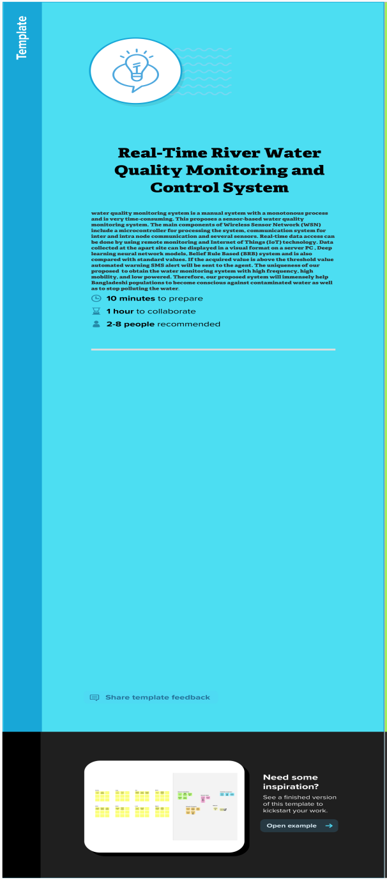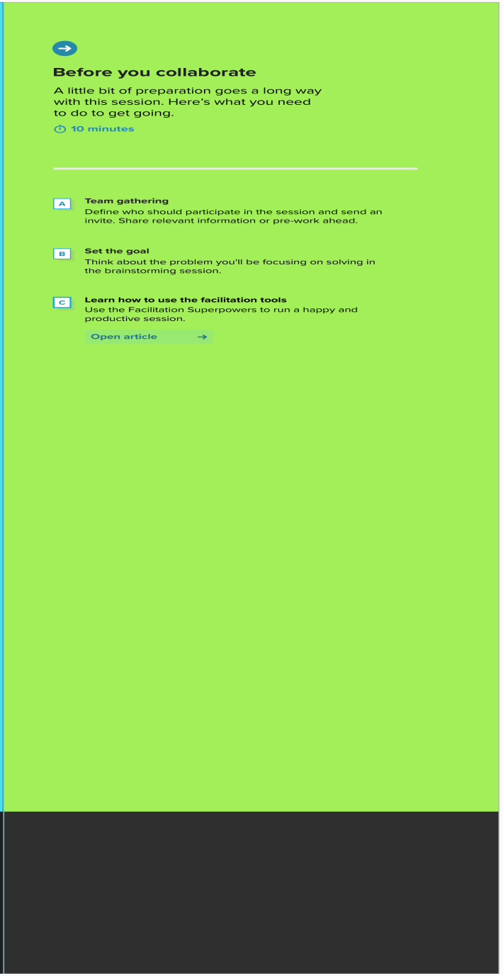

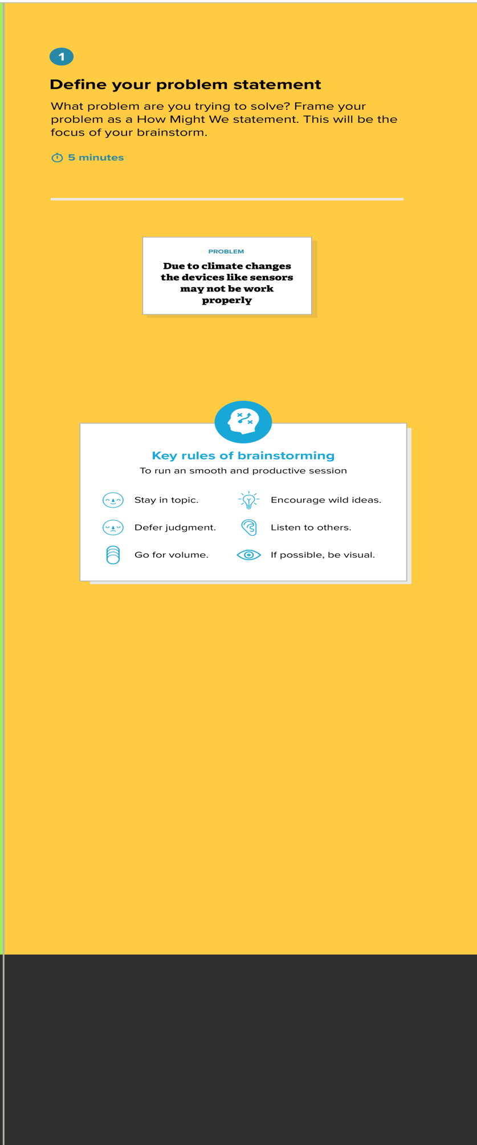

**Step-2: Brainstorm, Idea Listing and Grouping** 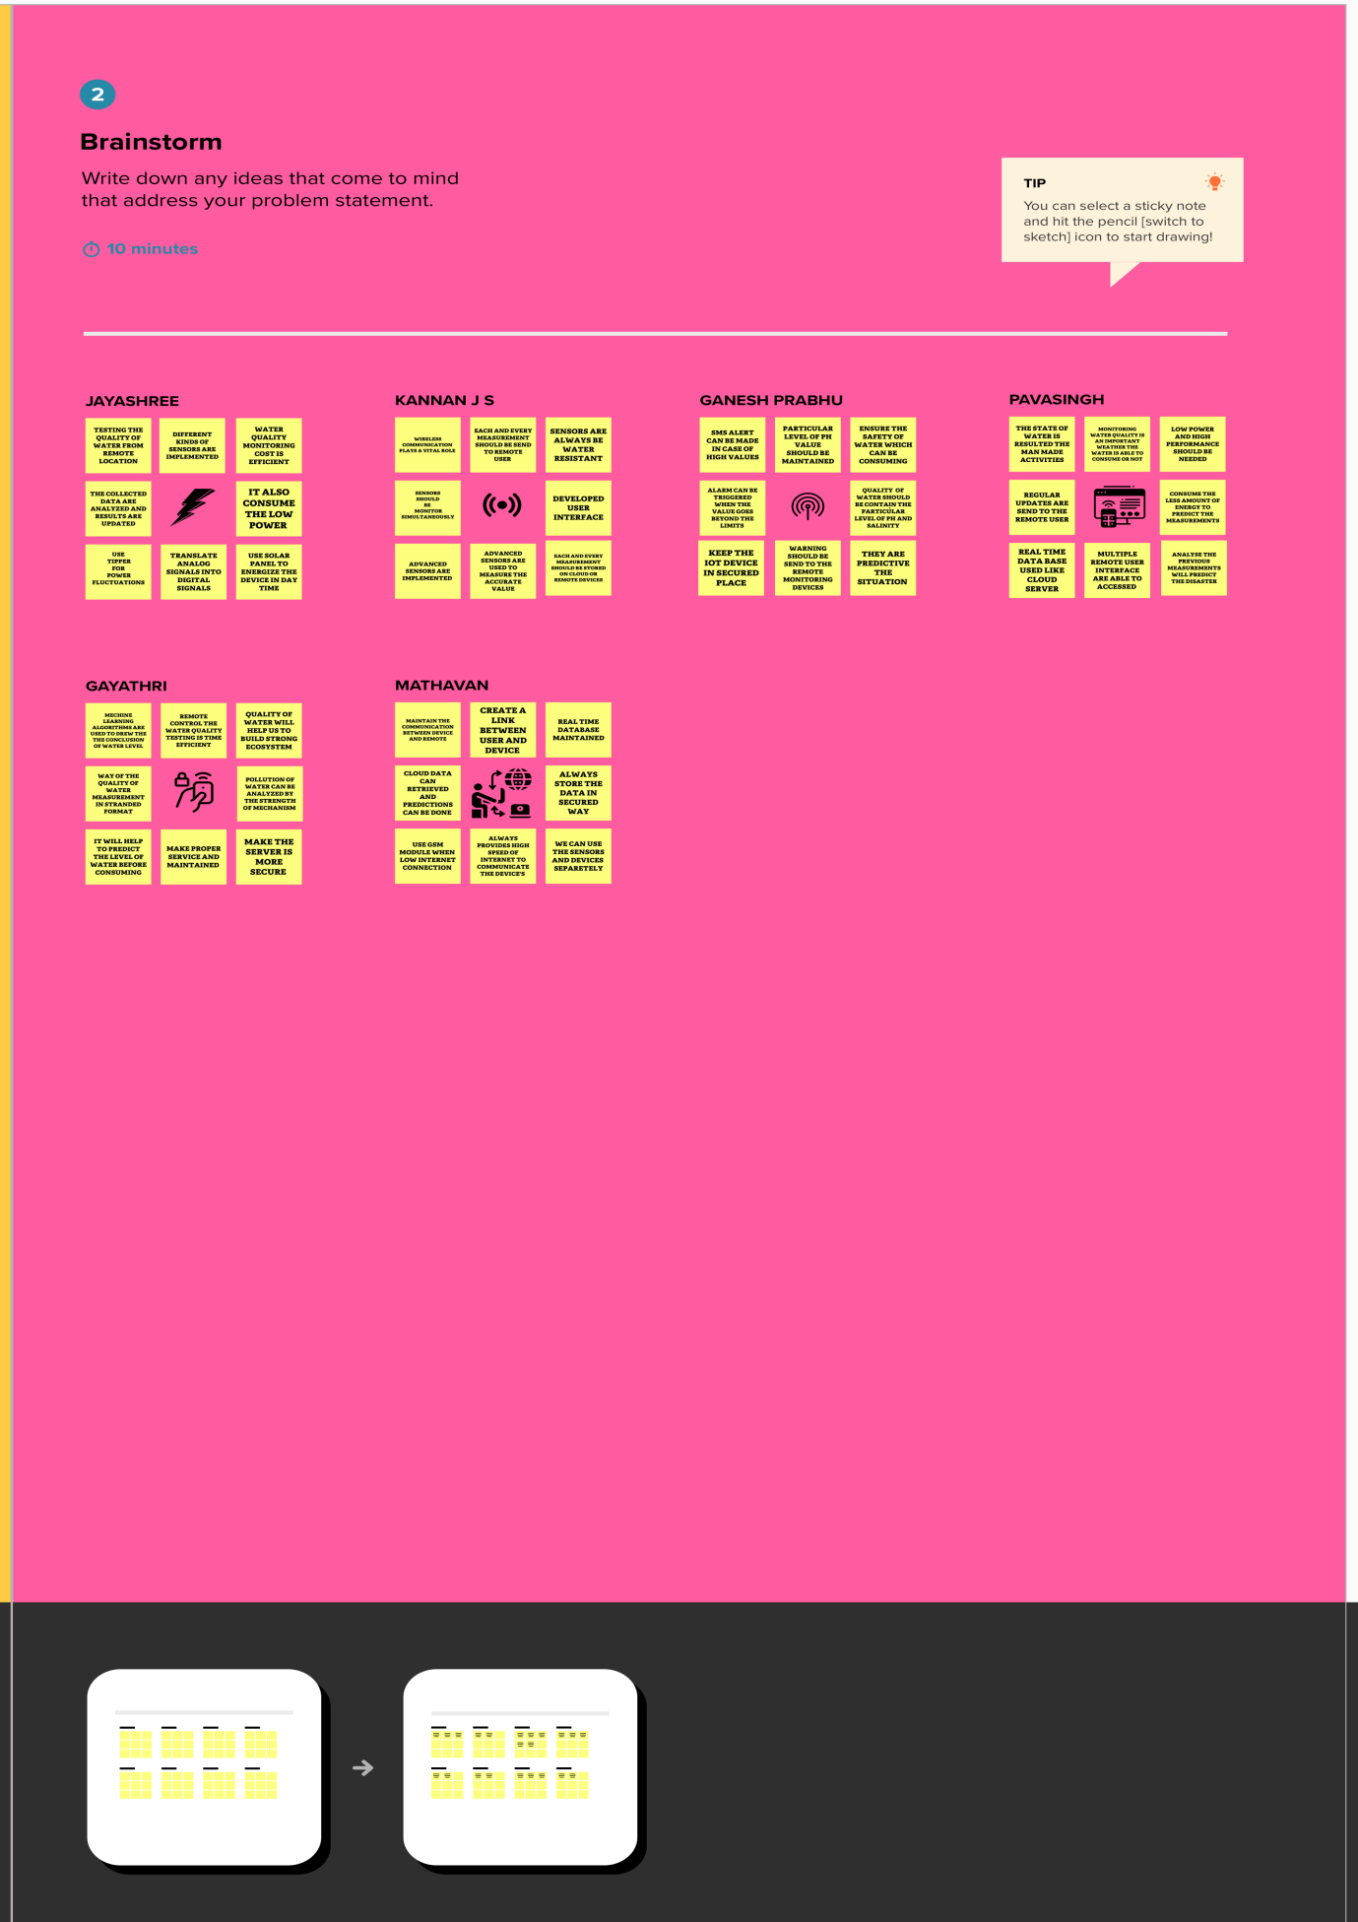

**STEP 3 GROUP IDEAS**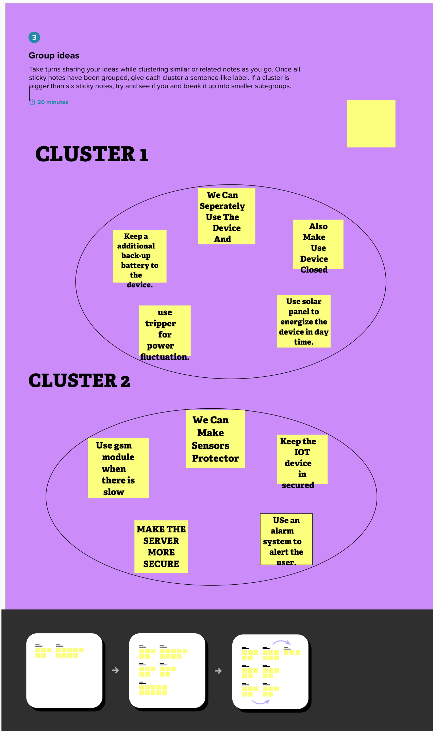

STEP 4:PRIORITIZE

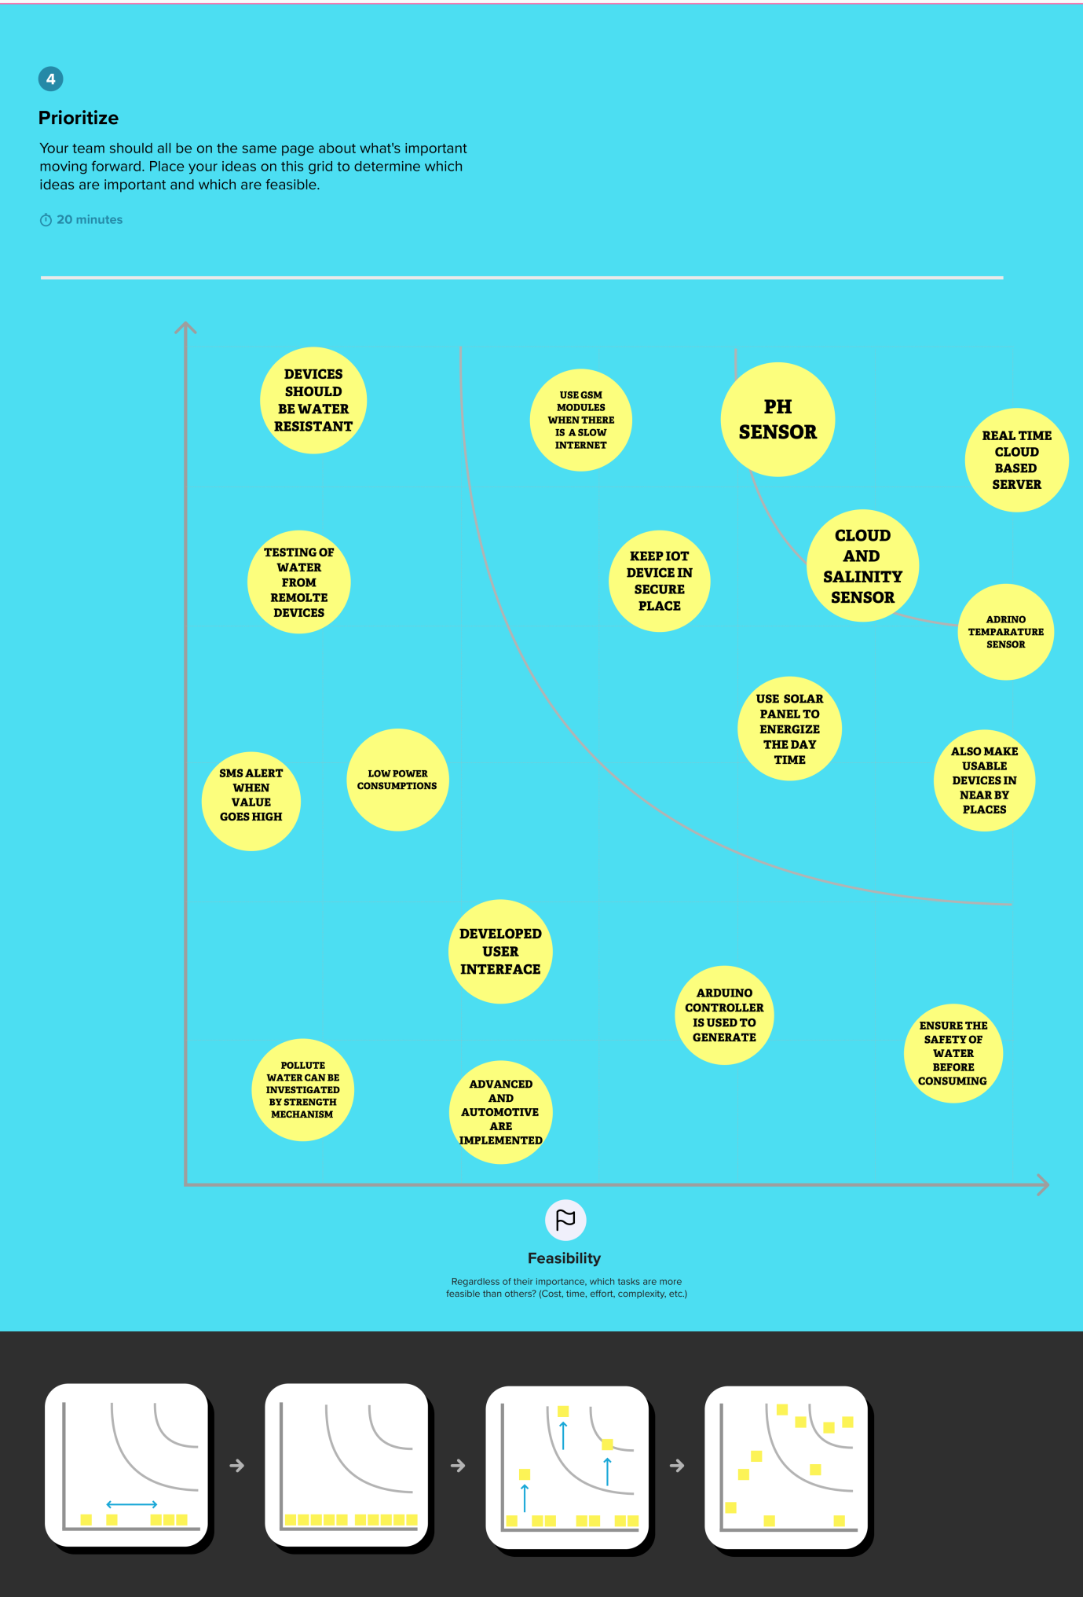AFTER YOU CLOBERATE

